Panel Clock Connections
- 32 x 32 RGB Matrix (See also AdaFruit tutorial on wiring and connections) for Arduino Mega:
  - CLK 11
  - OE 9
  - LAT 10
  - A A0
  - B A1
  - C A2
  - D A3
- Brightness LDR 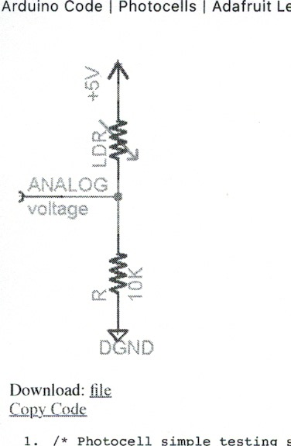
  - Positive 5v
  - Ground
  - Mega Pin A7 (analog)

- Set, Up and Down Buttons (SPST)
  - Ground on one side
  - Mega Pins 2,3 and 4 respectively
- Showoff/Demonstration Button
  - Ground
  - Mega Pin 7
- Automatic Night Shutoff Pin (ANSO)
  - Ground
  - Mega Pin 12
- Chime/Cuckoo Select (SPDT Center off)
  - Middle of switch contacts to Ground
  - Upper (Westminster Chimes) to Pin 5
  - Lower (Bell or Cuckoo) to Pin 6
- AdaFruit FX 2Mb SoundBoard
  - Ground to Ground
  - 5V Vin to 5 v (Positive)
  - Sound board activation pins 0-9 to Mega Pins 40-49 respectively
  - ACT Pin to Mega Pin 8
  - Speaker pins to 8 ohm speaker (no polarity)
- RTC 3231 Real time clock
  - Ground to Ground
  - Vin to 5v
  - SCL and SDA to SCL and SDA on Mega
- BME680 temperature, humidity and barometric pressure
  - Ground to Ground
  - Vin to 5v
  - SCL and SDA to SCL and SDA on Mega
- AC to DC adapter (4 or 5 amps)
  - 5v + wired directly to Arduino Mega, Sound Board, Matrix, LDR, RTC and BME680
  - Same for Ground (-5v) (i.e., no power drawn through the Arduino Mega)

