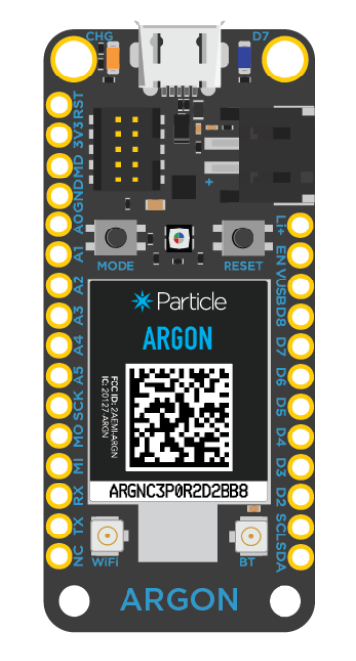
GND
A0
3V
Maria’s Argon Schematic
Temperature Sensor
No connections needed. Utilized built-in LED.
Haleigh’s Argon Schematic

