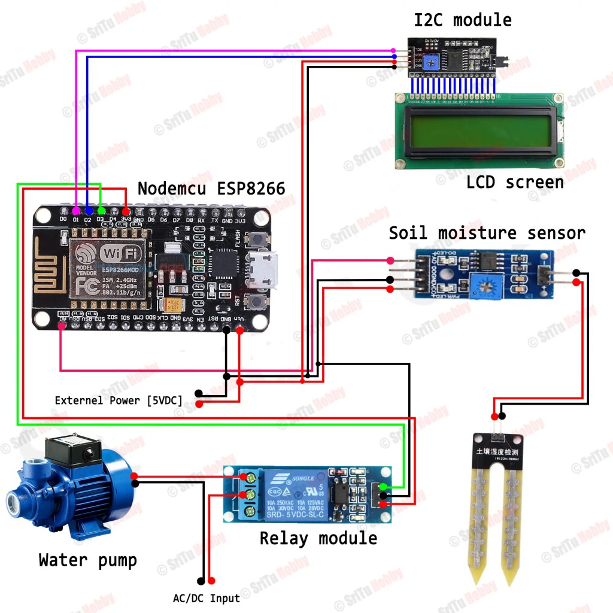
Connections :
16x2lcd display- VCC-VIN
GND-GND
SDA-D2
SCL-D1

5v relay -VCC-3V
GND-GND
IN-RX

Soil moisture sensor-AO-AO
VCC-VIN
GND-GND

