SCI4YOU
Training Cubesat

HISTORY
This project came to existence due to the need of generating development in research field, for it affects in all environments within a country; but what happens if all this environment seems to be meant for people with exceptional abilities with prodigious laboratories? It seems there is no incentive and it is preferred to go in another way. But what if instead of that, we could have access in an easy and practical way to a small cubesat that would facilitate our research and development environment? We could have a small researcher waiting to go out and achieve to create and understand things that are seen in everyday life, like for example, satellite transmission. How does a satellite manage to stay in the same position? How can it be programmed? How is the data transmission achieved? How does a sensor work? And all of this through a small device that is not aimed to entertain for a while, but to set a lifestyle.

Abstract
This project consists in the knowledge of the sensors that are either located in a cubesat or in a small satellite, rendering it more user-friendly through small useful apps that show the utility of every sensor with which the user can interact.

INTRODUCCION
This project consists of an application of the development kit HEXIWEAR on an educational platform of satellite training, on which it is intended, that the individue gets to know a bit more about the means of research employed in a learning environment, and since the kit is equipped with the necessary sensors to recreate the aspect of a basic satellite, his potential is going to be maximised for the development of this device.
Theoretical framework
HEXIWEA
For this project the following will be needed:
- Capacitive touch interface
- Temperature and humidity sensors
Operation range of humidity sensor: 0 a 100% RH
This sensor works within range between 0 to 100% for humidity, since it measures relative humidity (RH).
$$RH=\frac{Current steam density}{Saturacion steam density }*100$$
That means that the weigh generated by water within a specific area will be measured and it is the comparison of the relative humidity of the air with the maximum quantity of humidity that this one supports.
The following formula is used for the calculation of relative humidity
$$RH=-6+125\frac{t_{pw}(duracion del ciclo en alto del PWM)}{t_{f}(duracion de todo el cicloPWM)}*100$$

For temperature:
Operation range: -40°C A 125°C
$$Temp=-46.85+175.72*\frac{t_{pw}(duracion del ciclo en alto del PWM)}{t_{f}(duracion de todo el cicloPWM)}$$
- Pressure sensor
In order to get the height knowing the atmospheric pressure:
Operation range :20 Kpa y 110 Kpa
$h=44330.77 [1{-(\frac{p}{p_{0}})}^{0.1902632}$)+off_H(Register Value)
Where:
$p_{0}=101326$ pa sea level
off_H= Value offset 2 pa

- Gyroscope
Operation range:$±250°/s to ±2000°/s$
Working as a speedometer on the 3 axes showing the position of the object
- Speedometer
Operation range $±2g,±4g,±8g$
Other than the HEXIWEAR it will be needed:
- Encoder
The input of the sensor is the rotational speed (w), measured in RPM (one revolution per minute is one unit of frequency that is also used to express rotational speed).
Within this context, the number of completed rotations is indicated every minute for a body that spins around an axis.
The output of this sensor will be, pulses (periodical signal of variable frequency depending on the slot).
This particular sensor has a sensitivity of:
$$S_{c}=8\frac{Pulses}{Revolution}$$
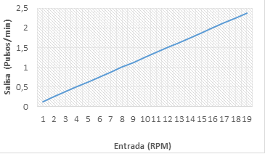
Fig. 2. Characteristic curve of the sensor.
To convert from RPA to ${Km}/h$, the following formula is used:

$$V=2πr*RPM*\frac{60}{1000}*\left(\frac{Km}{h}\right)$$

Where:

$$r:radius of the wheel$$

DISCRETIZER:

For this instrument a CAD is not necessary, because the sensor output is discrete (pulses).
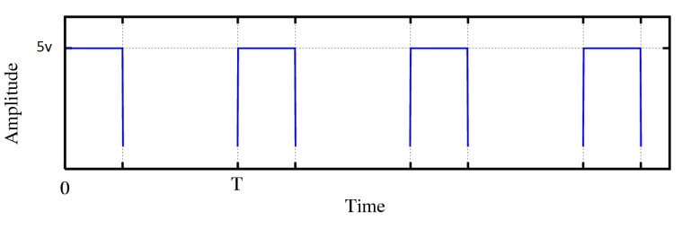
Figura 3. Sensor output

EMULATOR:

The emulation gives a maximum frequency of work for the signal that is emitted through the crystal of the microcontroller MK64FN1M0CAJ12R, i.e. the maximum velocity in which the instrument can be read is obtained because of the internal velocity of the emulator that is explained thus:

$$f=32 KHz$$

$$T=\frac{1}{f}=\frac{1}{32KHz}=31.65 μS$$

In order to make sure that every interruption is processed by the emulator, its frequency must be wider than the maximum frequency of the emulator.
In order to do that, we chose a limit value of $0,08μs$ that gives a velocity of $0,08μs*8 (ranuras)=0,64μs$. This is the minimum time a revolution can take.
With this we can find the maximum number of revolutions per minute that we can measure in the following way:
$$0.64x{10}^{-6 }s→1 revolution$$
$$60 s → x$$
$$x=60 s*\left(\frac{1 Revolution}{0,64*{10}^{-6} s}\right)=93´750.000 RPM$$
$$x=1´767.145 \frac{Km}{h}$$
Therefore the sensitivity of the emulator will be:
$$S_{e}=\frac{1}{S_{c}*S_{a}}=\frac{1}{\left(8*\frac{Pulsos}{Revolucion}\right)*\left(0,7\right)}$$

$$S_{e}=\frac{1}{5,6}*\frac{Revolución}{Pulso}$$

Lastly it can be said that the interrupter will be used to halt the measuring process and to start it again.
- Thermocouple

DEVELOPMENT OF THE PROJECT
The project consists in using the kit to show the usage of sensors through some experiments, and their functioning in a cubesat or a microsatellite, therefore the first experiment consists of a probability meter of a fire – recently, many fires have started in many parts of the world, and it is not known how to detect them at time so that they don’t come out of control – The cubesat will work as an intermediary between the sensors that are on orbit in the atmosphere over the place that will be supervised and will send information to different individuals, in this case, through an wireless Communicator (bluetooth) and a confortable interface for the users ca be to recieve the data .
Here will be used the application of the sensors:
- Temperature: for it is at very high temperatures that there is more probability of a fire.
- Of humidity since the le less humid the environment is, the higher the probability of a fire.
- Wind velocity: the encoder will be used; it is an element that makes it possible for fuels to oxidise. In agricultural fires, the direction of the wind determines where it is possible for the fire to transcend, because of gas and smoke convection primarily. The velocity of the wind makes the transference be faster.

-Another usage of the sensors is the measurement of humidity in plants, indicating if there is lack of water through a thermocouple, or also controlling the levels of light in the interior of the cube recreating an environment of living being.
- Here we see the research employment of the humidity sensor to keep a living being in an extra-terrestrial environment.
- The cubesat needs to keep a given orientation, known as the Attitude Determination.
-The gyroscope will be used as a guide here, since it will seek that the individual see how it acts, for the MINILAB will have a lever that will be positioned in the angle that guides the user from a fix point.

