Akhil Nambiar
CS 160
Assignment 1.1



Convertr is the worlds leading converter app. Created in Kinoma Studio.

Layout

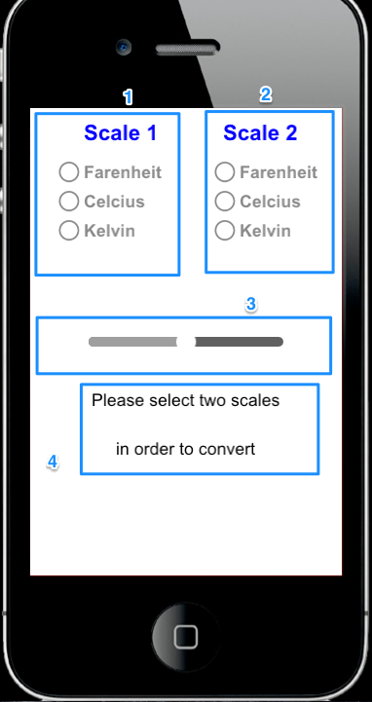
- Primary temperature Scale
- Secondary temperature scale
- Temperature Slider
- Display

Tutorial

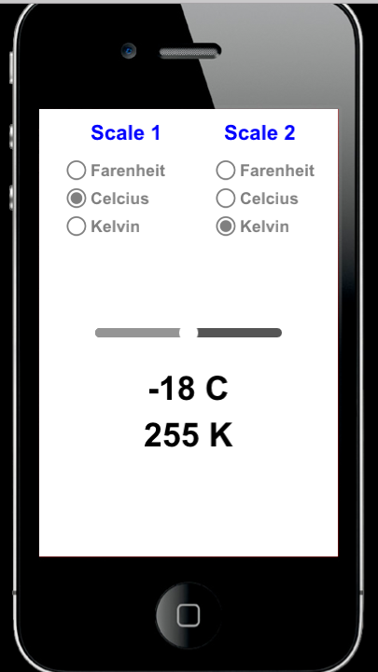
1) Select a primary and secondary scale by clicking on the radio buttons. If you do not choose an option from scale 1 and from scale 2, the initial instructions will not go away. Once you have selected one from each, degrees will show up in the display area.

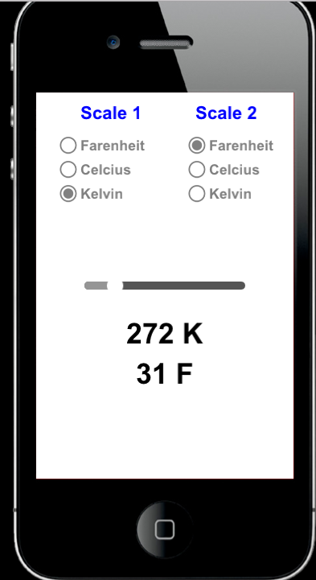
2) Click and Drag on the slider to change the temperature you are converting from. You will notice a change in both the top part of the display (which corresponds to scale 1), and the bottom part of the display (which corresponds to scale 2).

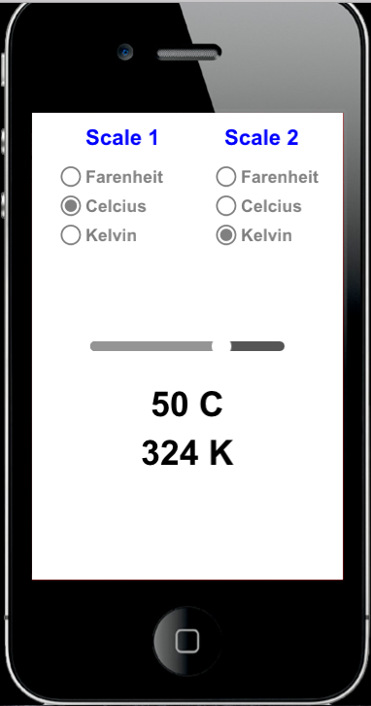
3) Mix and match what you want to convert between and enjoy!

