Full adder

Project ::
The full-adder circuit adds three one-bit binary numbers (C A B) and outputs two one-bit binary numbers, a sum (S) and a carry (C1).
Tools::
- Ic 74ls86 " XOR "
- Ic 74hct08 " AND"
- Ic 74hct32 "OR"
- leds .
- Push_button
- Cables
Operation ::
The full-adder circuit adds three one-bit binary numbers (C A B) and outputs two one-bit binary numbers, a sum (S) and a carry (C1).
Schematic::
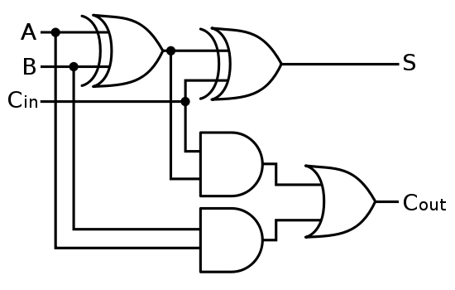

Truth table ::
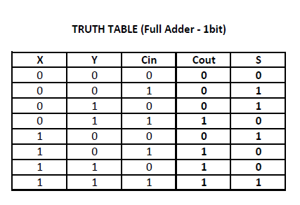
Simulation ::
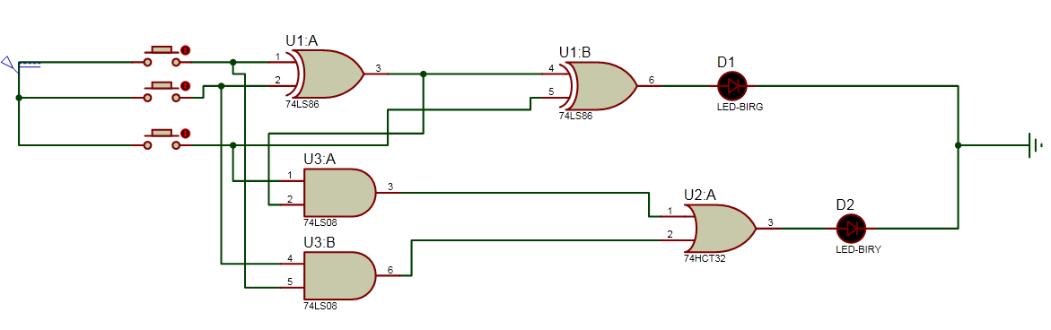
Data sheet of XOR $ AND $ OR
